Ruben Bettis
WR115
5/22/2014
Definition Essay(Community)
I don't believe that your location is an important part to your community is because I've learned from first hand experience, my favorite quote that expresses how I feel towards this idea is“ its not about where you are, its about where your going that defines you.”. When I hear this I interpret it as, where we are now is not relevant because its where were going that makes us who we are. One element that also plays a role in your community is the type of people you surround yourself with, and the reason why surrounding yourself with certain people plays a role in your community is because different people have different ideas of fun; which could have either a positive or negative affect on how you function as an individual in the community. Like how my friends from the smoking community have impacted my health by leading me to an unhealthy smoking addiction. However one of the most important things about your community should be that it should always be improving for the better; Changing surroundings and who you actually surround yourself with to benefit you is essential in a growing community. A change of community for myself might be just changing the crowd in which I associate myself with.
I live on 152nd in Beaverton, OR, but I go to school at PCC Rock Creek campus. The PCC campus that I go to is around the Hillsboro and Portland areas which is where I spend four out of the seven days of my week studying and hanging out with friends. So just because I live in Beaverton doesn't mean that's the community I belong to, but because I spend most of my time at PCC and most of my friends are at PCC, I am more of a member of the PCC community than a member of Beaverton. One of my best friends from PCC is my buddy named Nick, he's a student from Korea and we spend a lot of time hanging out with each other on campus. We have also gotten on such good terms with each other that he has invited me to a welcome home party that he is hosting when he comes back from Korea.
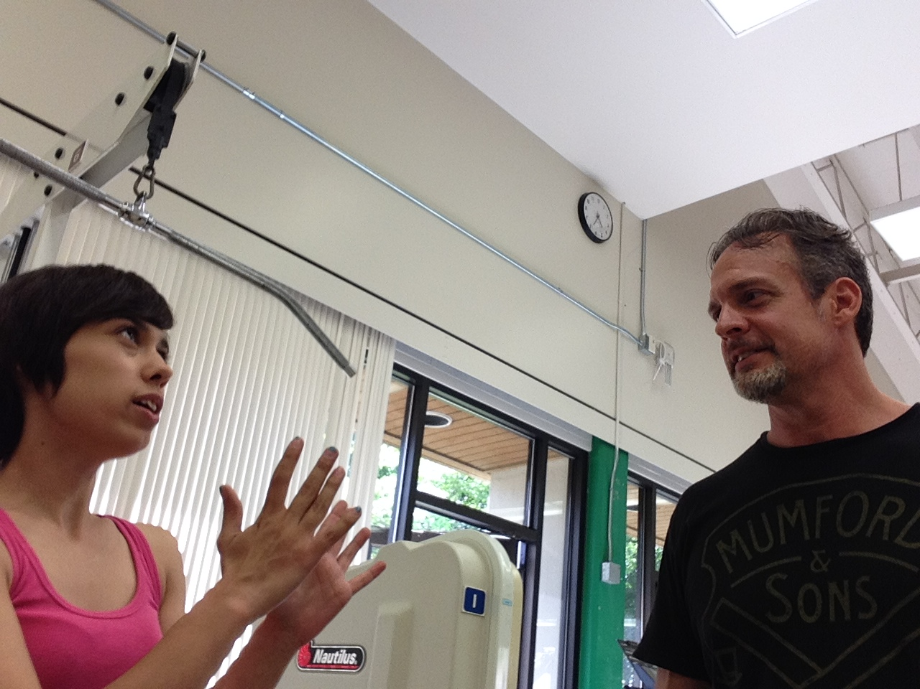
Being a member of the PCC community is quite a large category, so to better categorize how I fit into my community, I'll explain how community is also about who you surround yourself with. The type of community member I am at PCC would be better known as the “gym rat”. Of the four days I go to PCC to study, at least 3 of the days I visit the gym just to get in a workout before my next class. So I have become very fond of my P.E instructor, Spaz, who lets me come in the gym to lift or even volunteer.
Since my instructor has given me the privilege to enter the gym when its convenient to me, I've been able to volunteer in training some of his students who share similar fitness goals as me. So for the past three weeks I've been training with two different students this term, Tyler, and Jay. They both share a similar fitness goals, which are to increase their upper body strength to promote fat loss and gains in muscular size.
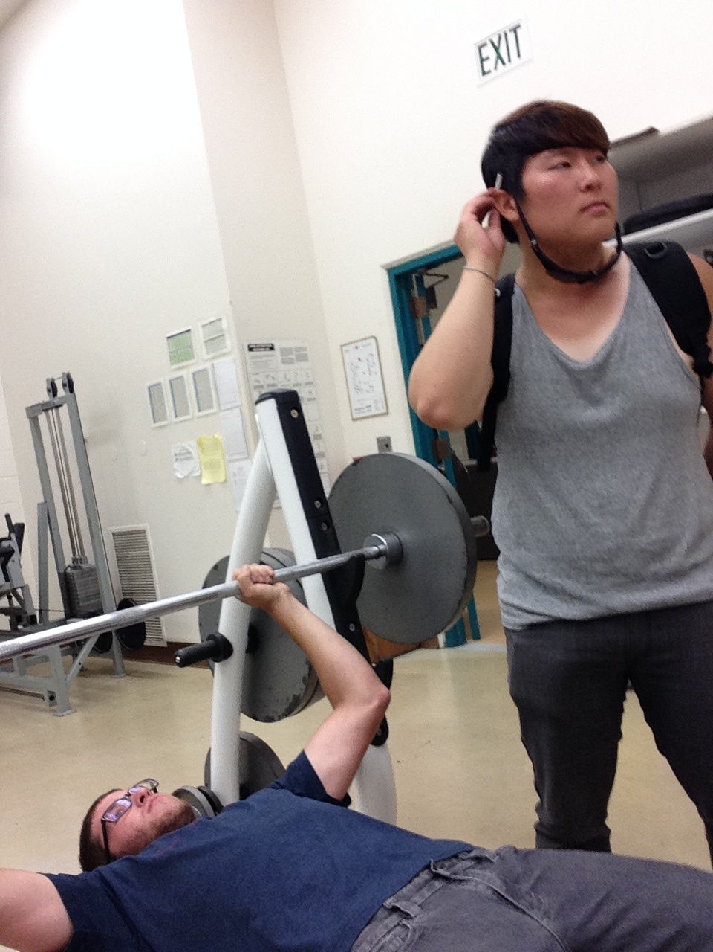
Through my volunteer experience in training P.E students and helping people reach their fitness goals, I've realized how hard it can be to train individuals, but also learned how fun it can be to; One thing that made it so difficult, is how Jay will sometimes lack the determination to work through the pain of a lift. They're were days where he would skip part of a lift session because he would rather play volley ball with the girls from the class over than focus on our group lifts. Although it was that same lack of determination that makes me try harder to inspire him to work through the pain, which is more often than not pretty fun; One time Jay spent the class period with the girls instead of with my lifting group, so me and Tyler had him do a type of shock workout. It was a surprise for both me and Tyler because the first workout that we could think of was the next movement we would make him do. It was a pain for Jay but entertaining for me and Tyler, we also encouraged him by helping him through and actually going through the movements with him.
Something positive I've walked away with from my time volunteering was, how to work with different peoples struggles. Tyler would often complain about having weaker upper body strength and how it effected him on some of our lifts, so I would take that into consideration in thinking up of a different lift to work similar muscles. Going into my future career I figure being able to adapt to peoples individual needs is a pretty important skill to develop. Overall I learned patients along with the ability to adapt to others particular fitness needs is important in being a good fitness instructor. I'm happy I've experienced this as soon as I did because I know its going to make me a better P.E teacher in the long run.
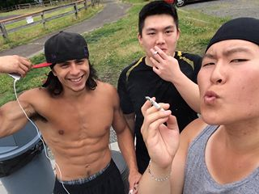
One thing that my new community has done to negatively affect how I function in the community is how I smoke cigarettes during my spare time to socialize with others. Since the smoking population at PCC is forced to banned together because PCC is a non tobacco use campus, it makes socializing a fun way to expand your community base and really get to know your neighbor on a more personal level. Smoking cigarettes has become something of a habit now, which is contradictory to what I'm working towards. I do feel guilty for smoking, especially when people ask me how I look in such great shape and smoke cigarettes. I know its not healthy at all for my body, and I do plan on quitting as soon as possible; So that I can set the bar for better standers with the people I train, but to also improve my own health and live the life I know I'm capable of living.
Communities can be an important quality to focus on when your trying to reach goals to bettering yourself. One thing I personally want to start doing to better myself, is becoming more involved with my fitness by exploring body building again. I have a friend named Tucker who is really pro health and fitness, and he is very interested into the whole body building scene. Back when I was into body building I remember having a similar mentality as Tucker, I loved the gym and didn't believe in any form of substance use or abuse. Working out or at least spending more time with Tucker in the gym would be something that I could do to better myself because it would inspire me to start making more positive changes in my life. Since Tucker is so pro health it will benefit me in my attempt to change because I feel like he could act as a support for me.
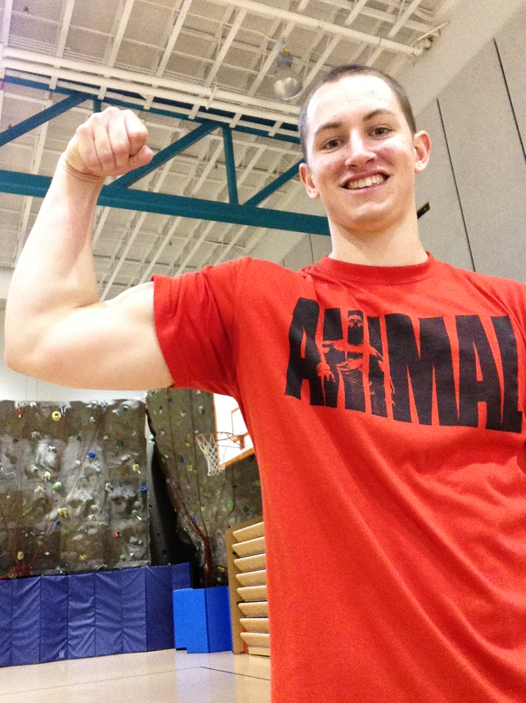
Even though it might be contrary to common belief, I feel that the true definition of community cannot be defined just based off where you live. Community starts with where you spend most of your time; An example could be how I live in Beaverton, but spend most of my days at PCC. Thus I am more a community member of PCC then I am a member of my own home city of Beaverton. Another important element to a community is all the smaller groups because it helps create a whole in the community. I personally fit into my community by being the 'gym rat' of PCC's building five gym. Helping other to strive towards their fitness goals, which is something I enjoy doing because I'm recognized by one of the instructors at the PCC gym as a someone who works hard and encourages other to do so. From my time volunteering at the PCC gym I've learned new skills that will help me towards my future profession, along with some new bad habits that I will have to learn and grow from. If there is one thing I learned from my time and experience from the community that I've surrounded myself with; I've learned that it is always important to keep moving toward the direction of success. So if it means to volunteer more, or even become part of a group it would be well worth you time.

http://youtu.be/turMGgVjdRI

